Appendix S2 - Length-mass conversion equations.

1. Equations used in this study
2. Sources and data for new equations developed here, rationale, and rationale for not including yet more new equations.
3. Examples of large differences in mass between squamates of a given length

Our aim in developing these equations is to have specific equations for all the clades (read: monophyletic families) for which we could derive allometric equations from a sufficient number of species (usually a minimum of 10, sometimes slightly lower, often much higher). In cases where we had good reasons to suspect there are very large differences within the clade (e.g., *Draco* vs. non-gliding agamids, *Phymaturus* vs. *Liolaemus*). When sample sizes for a family were insufficient (e.g., for all really small families) we used an equation based on more comprehensive an assemblage. 3. We do not use phylogenetic corrected equations as these cannot be used for prediction for species outside of the phylogeny. 4. Data on the fit of these equations can be found in the papers where we developed them (see list below). We did not use actual masses at all – except for the Tuatara. All masses except that of *Sphenodon* are based on lengths. We did not use the ecological factors identified by Feldman & Meiri (2013) for the equation because we lack the ecological data for many of the snakes that would have allowed us to infer their masses.

**Appendix S2a**

| **sub order** | **Group** | **Intercept** | **slope** | **length measure** | **mass equation from** |
| --- | --- | --- | --- | --- | --- |
| Serpentes | all snakes | -5.773 | 2.786 | SVL | Feldman and Meiri 2013 |
| Serpentes | Boidae | -5.500 | 2.776 | SVL | Feldman and Meiri 2013 |
| Serpentes | Elapidae | -4.892 | 2.453 | SVL | Feldman and Meiri 2013 |
| Serpentes | Homalopsidae | -7.713 | 3.631 | SVL | Feldman and Meiri 2013 |
| Serpentes | Lamprophiidae | -7.092 | 3.232 | SVL | Feldman and Meiri 2013 |
| Serpentes | Viperidae | -5.165 | 2.655 | SVL | Feldman and Meiri 2013 |
| Serpentes | all snakes | -5.465 | 2.597 | Total-length | Feldman and Meiri 2013 |
| Serpentes | all snakes | -5.465 | 2.597 | Total-length | Feldman and Meiri 2013 |
| Serpentes | Boidae | -5.886 | 2.856 | Total-length | Feldman and Meiri 2013 |
| Serpentes | Colubridae (Sensu lato) | -4.912 | 2.340 | Total-length | Feldman and Meiri 2013 |
| Serpentes | Elapidae | -4.819 | 2.407 | Total-length | Feldman and Meiri 2013 |
| Serpentes | Homalopsidae | -8.021 | 3.617 | Total-length | Feldman and Meiri 2013 |
| Serpentes | Lamprophiidae | -6.286 | 2.821 | Total-length | Feldman and Meiri 2013 |
| Serpentes | Scolecophidia | -6.596 | 3.068 | Total-length | Feldman and Meiri 2013 |
| Serpentes | Viperidae | -6.013 | 2.910 | Total-length | Feldman and Meiri 2013 |
| Amphisbaenia | Amphisbaenia | -5.858 | 2.943 | SVL | Meiri 2010 |
| Amphisbaenia | Amphisbaenidae | -8.647 | 4.007 | SVL | Meiri 2010 |
| Sauria | Anguimorpha | -5.058 | 3.145 | SVL | Meiri 2010 |
| Sauria | Chamaeleonidae | -3.997 | 2.680 | SVL | Meiri 2010 |
| Sauria | Gerrhosauridae | -4.783 | 3.085 | SVL | Meiri 2010 |
| Sauria | Iguania | -5.033 | 3.243 | SVL | Meiri 2010 |
| Sauria | Iguanidae | -4.298 | 2.972 | SVL | Meiri 2010 |
| Sauria | Lacertidae | -4.543 | 2.951 | SVL | Meiri 2010 |
| Sauria | Legged Cordylidae | -5.747 | 3.589 | SVL | Meiri 2010 |
| Sauria | Legged Gymnophthalmidae | -5.178 | 3.302 | SVL | Meiri 2010 |
| Sauria | Legged Scincidae | -5.125 | 3.229 | SVL | Meiri 2010 |
| Sauria | leg-reduced lizards | -4.207 | 2.471 | SVL | Meiri 2010 |
| Sauria | Limbless lizards | -4.207 | 2.300 | SVL | Meiri 2010 |
| Sauria | Opluridae | -6.439 | 3.940 | SVL | Meiri 2010 |
| Sauria | Phrynosomatidae | -3.855 | 2.677 | SVL | Meiri 2010 |
| Sauria | Polychrotidae | -4.583 | 2.940 | SVL | Meiri 2010 |
| Sauria | Pygopodidae | -2.039 | 1.371 | SVL | Meiri 2010 |
| Sauria | Teiidae | -4.747 | 3.110 | SVL | Meiri 2010 |
| Sauria | Tropiduridae senso lato | -4.216 | 2.846 | SVL | Meiri 2010 |
| Sauria | Varanidae | -5.301 | 3.235 | SVL | Meiri 2010 |
| Sauria | Xantusiidae | -4.796 | 3.048 | SVL | Meiri 2010 |
| Sauria | Fully legged anguids | -5.765 | 3.480 | SVL | Meiri et al. 2013 |
| Sauria | Anolis | -4.574 | 2.942 | SVL | Novosolov et al. 2013 |
| Sauria | Eublepharidae | -5.201 | 3.255 | SVL | Novosolov et al. 2013 |
| Sauria | Gekkonidae | -4.242 | 2.761 | SVL | Novosolov et al. 2013 |
| Sauria | Sphaerodactylidae | -4.558 | 2.970 | SVL | Novosolov et al. 2013 |
| Sauria | Liolaeumus | -4.678 | 3.097 | SVL | Pincheira-Donoso et al. 2011 |
| Sauria | Phymaturus | -5.040 | 3.323 | SVL | Pincheira-Donoso et al. 2011 |
| Sauria | Carphodactylidae | -3.445 | 2.353 | SVL | Scharf et al. 2015 |
| Sauria | Diplodactylidae | -4.804 | 3.057 | SVL | Scharf et al. 2015 |
| Sauria | Phyllodactylidae | -4.482 | 2.945 | SVL | Scharf et al. 2015 |
| Sauria | Tropiduridae (Sensu stricto) | -3.884 | 2.719 | SVL | Scharf et al. 2015 |
| Serpentes | Colubridae | -5.548 | 2.539 | Total-length | Scharf et al. 2015 |
| Serpentes | Dipsadidae | -4.715 | 2.278 | Total-length | Scharf et al. 2015 |
| Serpentes | Natricidae | -7.456 | 3.303 | Total-length | Scharf et al. 2015 |
| Serpentes | Pythonidae | -5.216 | 2.652 | Total-length | Scharf et al. 2015 |
| Serpentes | Typhlopidae | -8.012 | 3.693 | Total-length | Scharf et al. 2015 |
| Sauria | Agamidae (Typical)** | -4.686 | 3.105 | SVL | this study (appendix 2b) |
| Sauria | Draco** | -4.310 | 2.642 | SVL | this study (appendix 2b) |
| Sauria | Crotaphytidae | -1.528 | 1.569 | SVL | this study (appendix 2b) |
| Sauria | Leiosauridae | -5.296 | 3.389 | SVL | this study (appendix 2b) |
| Sauria | Limbless anguids | -5.224 | 2.892 | SVL | this study (appendix 2b) |
| Sauria | Xenosauridae | -5.833 | 3.571 | SVL | this study (appendix 2b) |
| Serpentes | Colubridae** | -5.525 | 2.627 | SVL | this study (appendix 2b) |
| Serpentes | Dipsadidae** | -4.948 | 2.450 | SVL | this study (appendix 2b) |
| Serpentes | Leptotyphlopidae** | -4.709 | 2.234 | SVL | this study (appendix 2b) |
| Serpentes | Natricidae** | -6.223 | 2.982 | SVL | this study (appendix 2b) |
| Serpentes | Pythonidae** | -5.222 | 2.688 | SVL | this study (appendix 2b) |
| Serpentes | Typhlopidae** | -10.919 | 4.954 | SVL | this study (appendix 2b) |
| Serpentes | Leptotyphlopidae** | -4.641 | 2.173 | Total-length | this study (appendix 2b) |

Feldman, A. and Meiri, S. 2013. Length–mass allometry in snakes. Biological Journal of the Linnean Society, 108: 161-182.

Meiri, S. 2010. Length–weight allometries in lizards. Journal of Zoology 281: 218-226.

Meiri, S., Bauer, A. M., Chirio, L., Colli, G. R., Das, I., Doan, T. M., Feldman, A., Herrera, F-C., Novosolov, M., Pafilis, P., Pincheira-Donoso, D., Powney, G., Torres-Carvajal, O., Uetz, P. and Van Damme, R. 2013. Are lizards feeling the heat? A tale of ecology and evolution under two temperatures. Global Ecology and Biogeography 22: 834-845.

Novosolov, M., Raia, P. and Meiri, S. 2013. The island syndrome in lizards. Global Ecology and Biogeography, 22: 184-191.

Pincheira-Donoso, D., Fox, S. F., Scolaro, J. A., Ibargüengoytia, N. Acosta, J. C., Corbalan, V., Medina, M., Boretto, J., Villavicencio, H. J. and Hodgson, D. J. 2011. Body size dimensions in lizard ecological and evolutionary research: exploring the predictive power of mass estimation equations in two Liolaemidae radiations. Herpetological Journal 21: 35-42.

Scharf, I., Feldman, A., Novosolov, M., Pincheira-Donoso, D., Das, I., Bohm, M., Uetz, P., Torres-Carvajal, O., Bauer, A. M., Roll, U. and Meiri, S. 2015. Late bloomers and baby boomers: ecological drivers of longevity in squamates and the tuatara. Global Ecology and Biogeography 24: 396-405.

**Appendix S2b**

We re-checked the equations of several taxa due to both the existence of forms that we thought were either generally heavier (*Phrynosoma, Uromastyx* sensu lato), or generally lighter (*Draco*) than closely related species of the same length. We also developed new allometric equations following suggested taxonomic re-arrangements (i.e. splits) in some of the taxa for which we had more general equations.

For some taxa we found little evidence for a necessity to provide new equations following some recent, controversial taxonomic suggestions (e.g., putative families of skinks, and the splitting of the Anguidae into Anguidae and Diploglossidae, see Figures S1 and S2 below). In the Phrynosomatidae we found differences in the mass-length relationship between the two subfamilies. However members of the *Sceloporinae* seem to be generally heavier than Phrynosomatinae of the same length – except for *Phrynosoma* which are heavier still (see Figure S3 below). We therefore retained the equations of Meiri (2010) for these two families.

In the Agamidae (Table S1), to our surprise, we did not see large differences between the mass-length relationship of the wide-bodied Uromasticinae and other taxa. Members of the gliding Southeast Asian genus *Draco,* however, are much lighter than agamids of comparable length (see Figure S4). We therefore developed new equations for the Agamidae: one for the genus Draco and one for all other agamids, based on data in Table S1. In deriving new equations for agamids we preferred masses of males when data for both sexes were available, because female mass is likely to be more greatly affected by reproductive condition than male size (although we did not use female masses when the female was known to be pregnant, and used post-partum masses when those were reported). We only used data for unsexed specimens if no data were available for specimens of known sex. When possible (for 106 species) we used data from the same publication for both weight and SVL. For three species we could only find weight data in one publication and SVL data in another.

We present new family-level equations for the Crotaphytidae (Table S2), Leiosauridae (Table S3), Limbless anguids (Table S4) and Xenosauridae (Table S5).

For iguanian families that were recently split (e.g., from Tropiduridae or Polychrotidae – including Polychrotidae *sensu stricto* [most data for this family in Meiri 2010 were for *Anolis*) and for which we do not have a new family-level equation (or genus level in the case of *Ctenoblepharys adspersa*) we used the equation for Iguania from Meiri (2010).

For snakes we developed new equations for families that were recently split (i.e., former subfamilies of Colubridae), from length and mass data already presented in Feldman and Meiri (2013), by simply allocating species to the newly recognized families according to the taxonomy of Uetz (2014) which we follow in this work. For such new families with no suitable data (e.g., Pseudoxenodontidae) we used the equation of Colubridae (Sensu lato; Feldman and Meiri 2013). In the Scolecophidia we found differences between the mass-length relationship of Leptotyphlopidae and Typhlopidae and use an equation for Typhlopidae from Scharf et al. (2014). We present here new equations for the Leptotyphlopidae (data from Feldman and Meiri 2013).

**Table S1**

Agamid lengths and masses

| **sub-family** | **Species** | **source** | **mean SVL (mm)** | **mean mass (g)** | **n (# of animals)** | **sex** |
| --- | --- | --- | --- | --- | --- | --- |
| Agaminae | *Acanthocercus atricollis* | TAUM | 118.6897 | 48.8931 | 29 | male |
| Agaminae | *Acanthocercus cyanogaster* | TAUM | 107 | 39 | 1 | unsexed |
| Agaminae | *Acanthocercus phillipsii* | TAUM | 68.5 | 9.5 | 2 | unsexed |
| Agaminae | *Agama aculeata* | Jacobsen 1982 | 56.6 | 6.58 | 5 | unsexed |
| Agaminae | *Agama agama* | TAUM | 117.0455 | 51.04545 | 22 | male |
| Agaminae | *Agama atra* | TAUM | 105 | 24.4 | 1 | unsexed |
| Agaminae | *Agama caudospinosa* | TAUM | 130.8182 | 82.11818 | 11 | male |
| Agaminae | *Agama hispida* | Costa et al. 2008 | 66.6 | 14.07 | NA | unsexed |
| Agaminae | *Agama impalearis* | TAUM | 104.8333 | 36.91667 | 12 | male |
| Agaminae | *Agama lionotus* | TAUM | 117.25 | 51.54375 | 48 | male |
| Agaminae | *Agama mwanzae* | TAUM | 118.375 | 54.1875 | 8 | male |
| Agaminae | *Agama planiceps* | TAUM | 108.5 | 29.55 | 2 | male |
| Agaminae | *Agama rueppelli* | TAUM | 77.32 | 20.208 | 25 | unsexed |
| Agaminae | *Coryphophylax subcristatus* | Krishnan 2005 | 79.65108 | 14.89684 | 212 | unsexed |
| Agaminae | *Laudakia tuberculata* | Fleming et al. 2013 | 150 | 94.2 | NA | unsexed |
| Agaminae | *Paralaudakia caucasia* | TAUM | 126.5714 | 53.88571 | 14 | unsexed |
| Agaminae | *Paralaudakia lehmanni* | TAUM | 117 | 54.94 | 5 | unsexed |
| Agaminae | *Phrynocephalus axillaris* | Sun et al. 2012 | 48.4 | 3.3 | 34 | female |
| Agaminae | *Phrynocephalus forsythii* | Sun et al. 2012 | 53.3 | 4.6 | 39 | female |
| Agaminae | *Phrynocephalus guttatus* | Rogovin and Semenov 2002 (SVL), Rogovin and Semenov 2004 (mass) | 48.82 | 4.06 | NA | male |
| Agaminae | *Phrynocephalus helioscopus* | TAUM | 54 | 6.9 | 2 | unsexed |
| Agaminae | *Phrynocephalus interscapularis* | TAUM | 34 | 0.9 | 4 | male |
| Agaminae | *Phrynocephalus mystaceus* | TAUM | 90 | 28.3 | 1 | female |
| Agaminae | *Phrynocephalus przewalskii* | Qu et al. 2011 | 51.2 | 3.931818 | 89 | female |
| Agaminae | *Phrynocephalus putjatai* | Ji et al. 2009 | 72.05 | 11.1 | 14 | female |
| Agaminae | *Phrynocephalus versicolor* | Qu et al. 2011 | 52.8 | 4.386364 | 134 | female |
| Agaminae | *Phrynocephalus vlangalii* | Jin and Liu 2007 | 58.89549 | 8.951316 | 266 | female |
| Agaminae | *Psammophilus dorsalis* | Radder et al. 2006 | 102 | 40 | NA | male |
| Agaminae | *Pseudotrapelus sinaitus* | TAUM | 78.28571 | 15.02857 | 35 | male |
| Agaminae | *Rankinia diemensis* | Stuart-Smith et al. 2008 | 66.3 | 10 | NA | female |
| Agaminae | *Sitana ponticeriana* | Radder and Shanbhag 2003 | 62.2 | 6.84 | 29 | female |
| Agaminae | *Stellagama stellio* | TAUM | 112.0958 | 60.68269 | 52 | male |
| Agaminae | *Trapelus agilis* | TAUM | 100 | 35.5 | 35.5 | male |
| Agaminae | *Trapelus agnetae* | TAUM | 64.24848 | 9.121212 | 33 | male |
| Agaminae | *Trapelus sanguinolentus* | TAUM | 91.42857 | 21.18571 | 7 | unsexed |
| Agaminae | *Trapelus savignii* | TAUM | 81.07381 | 18.25714 | 21 | male |
| Amphibolurinae | *Amphibolurus muricatus* | Fleming et al. 2013 | 100 | 60 | NA | unsexed |
| Amphibolurinae | *Amphibolurus norrisi* | Brown 2012 | 90 | 20 | NA | unsexed |
| Amphibolurinae | *Chlamydosaurus kingii* | Bedford et al. 1993 | 210.3333 | 240.3333 | 9 | female |
| Amphibolurinae | *Ctenophorus adelaidensis* | Fleming et al. 2013 | 35.52 | 1.97 | NA | unsexed |
| Amphibolurinae | *Ctenophorus clayi* | Costa et al. 2008 | 41.6 | 2.7 | NA | unsexed |
| Amphibolurinae | *Ctenophorus fionni* | Johnston 2005 | 71.5 | 14 | 1 | male |
| Amphibolurinae | *Ctenophorus fordi* | Costa et al. 2008 | 48.3 | 2.7 | NA | unsexed |
| Amphibolurinae | *Ctenophorus isolepis* | Costa et al. 2008 | 51.4 | 5.48 | NA | unsexed |
| Amphibolurinae | *Ctenophorus maculatus* | Fleming et al. 2013 | 64.6 | 8.8 | NA | unsexed |
| Amphibolurinae | *Ctenophorus maculosus* | Olsson 1995 | 62.47895 | 7.508065 | 62 | male |
| Amphibolurinae | *Ctenophorus nuchalis* | Light et al. 1966 | 127 | 40 | 1 | male |
| Amphibolurinae | *Ctenophorus pictus* | Henle 1989 | 55 | 8 | 2 | unsexed |
| Amphibolurinae | *Ctenophorus reticulatus* | Costa et al. 2008 | 72.3 | 15.08 | NA | unsexed |
| Amphibolurinae | *Ctenophorus scutulatus* | Costa et al. 2008 | 74.8 | 18.29 | NA | unsexed |
| Amphibolurinae | *Diporiphora bilineata* | Sadlier 1990 | 55 | 4.25 | NA | unsexed |
| Amphibolurinae | *Diporiphora winneckei* | Costa et al. 2008 | 43.8 | 2.51 | NA | unsexed |
| Amphibolurinae | *Hypsilurus boydii* | Brown 2012 | 150 | 145 | NA | unsexed |
| Amphibolurinae | *Hypsilurus spinipes* | Brown 2012 | 120 | 55 | NA | unsexed |
| Amphibolurinae | *Intellagama lesueurii* | Brown 2012 | 210 | 375 | NA | unsexed |
| Amphibolurinae | *Lophognathus longirostris* | Costa et al. 2008 | 64 | 10.42 | NA | unsexed |
| Amphibolurinae | *Lophognathus temporalis* | Iglesias et al. 2012 | 116.6571 | 54.10571 | 45 | male |
| Amphibolurinae | *Moloch horridus* | Bush 1992 | 91 | 38 | 1 | female |
| Amphibolurinae | *Physignathus cocincinus* | TAUM | 185 | 302.95 | 2 | unsexed |
| Amphibolurinae | *Pogona barbata* | TAUM | 201.4667 | 235.5467 | 15 | unsexed |
| Amphibolurinae | *Pogona henrylawsoni* | Turner and Valentic 1998 | 119.5 | 70 | 2 | male |
| Amphibolurinae | *Pogona minor* | Costa et al. 2008 | 100.4 | 42.11 | NA | unsexed |
| Amphibolurinae | *Tympanocryptis lineata* | TAUM | 70 | 7 | 1 | unsexed |
| Amphibolurinae | *Tympanocryptis tetraporophora* | Greer and Smith 2000 | 51.1 | 4.81 | 13 | male |
| Draconinae | *Acanthosaura coronata* | Jestrzemski et al. 2013 | 73.82 | 13.36 | 1 | unsexed |
| Draconinae | *Acanthosaura nataliae* | Jestrzemski et al. 2013 | 114.5 | 42 | 2 | unsexed |
| Draconinae | *Calotes aurantolabium* | Krishnan 2008 | 67.9 | 6.3 | 1 | female |
| Draconinae | *Calotes calotes* | TAUM | 101 | 38.2 | 1 | unsexed |
| Draconinae | *Calotes mystaceus* | Hartmann et al. 2013 | 114.1 | 56 | 1 | male |
| Draconinae | *Calotes rouxii* | Shanbhag et al. 2010) | 70.3 | 10 | 1 | male |
| Draconinae | *Calotes versicolor* | Ji et al. 2002 | 90.1 | 16 | 117 | male |
| Draconinae | *Draco beccarii* | McGuire 1998 | 68.79 | 3.61 | 17 | male |
| Draconinae | *Draco biaro* | McGuire 1998 | 73.5 | 4.23 | 5 | male |
| Draconinae | *Draco bimaculatus* | McGuire 1998 | 66.71 | 3.03 | 26 | male |
| Draconinae | *Draco blanfordii* | McGuire 1998 | 122.4 | 14.18 | 20 | male |
| Draconinae | *Draco caerulhians* | McGuire 1998 | 71.254 | 3.57 | 6 | male |
| Draconinae | *Draco cornutus* | McGuire 1998 | 76.25 | 4.23 | 4 | male |
| Draconinae | *Draco cristatellus* | McGuire 1998 | 85 | 9.9 | 1 | female |
| Draconinae | *Draco cyanopterus* | McGuire 1998 | 87.83 | 8.27 | 3 | male |
| Draconinae | *Draco fimbriatus* | McGuire 1998 | 110.33 | 16.9 | 3 | male |
| Draconinae | *Draco guentheri* | McGuire 1998 | 71.5 | 4.4 | 2 | male |
| Draconinae | *Draco haematopogon* | McGuire 1998 | 80.25 | 4.89 | 14 | male |
| Draconinae | *Draco lineatus* | McGuire 1998 | 77.75 | 5.2 | 20 | male |
| Draconinae | *Draco maculatus* | McGuire 1998 | 78.83 | 5.59 | 12 | male |
| Draconinae | *Draco maximus* | McGuire 1998 | 139.63 | 22 | 8 | male |
| Draconinae | *Draco melanopogon* | McGuire 1998 | 79.79 | 3.66 | 43 | male |
| Draconinae | *Draco mindanensis* | McGuire 1998 | 96.5 | 7.28 | 4 | male |
| Draconinae | *Draco obscurus* | McGuire 1998 | 96 | 8.1 | 4 | male |
| Draconinae | *Draco ornatus* | McGuire 1998 | 75.58 | 4.66 | 6 | male |
| Draconinae | *Draco palawanensis* | McGuire 1998 | 77.69 | 4.61 | 8 | male |
| Draconinae | *Draco quadrasi* | McGuire 1998 | 69.75 | 3.5 | 2 | male |
| Draconinae | *Draco quinquefasciatus* | McGuire 1998 | 101.5 | 7.82 | 7 | male |
| Draconinae | *Draco reticulatus* | McGuire 1998 | 63.21 | 2.97 | 10 | male |
| Draconinae | *Draco spilopterus* | McGuire 1998 | 78.576 | 4.816 | 35 | male |
| Draconinae | *Draco sumatranus* | McGuire 1998 | 77.36 | 4.7 | 11 | male |
| Draconinae | *Draco taeniopterus* | McGuire 1998 | 73.47 | 3.78 | 16 | male |
| Draconinae | *Draco volans* | McGuire 1998 | 70 | 3.5 | 5 | male |
| Draconinae | *Japalura brevipes* | Huang 1997 | 65.83 | 7.55 | 13 | female |
| Draconinae | *Japalura swinhonis* | Huang 2007 | 74.58 | 11.24 | 89 | male |
| Draconinae | *Otocryptis wiegmanni* | Erdelen 1998 | 69.2 | 8 | 1 | male |
| Draconinae | *Pseudocalotes andamanensis* | Krishnan 2008 | 84.1 | 12.5 | 1 | male |
| Draconinae | *Pseudocalotes larutensis* | Hallermann and McGuire 2001 | 77.3 | 7.1 | 1 | male |
| Leiolepidinae | *Leiolepis reevesii* | Du et al. 2011 | 101.4 | 20.45724 | 200 | female |
| Uromastycinae | *Saara hardwickii* | Minton 1966 (SVL), Qureshi et al. 2012 (weight) | 177 | 263.4 | 6/20 | male |
| Uromastycinae | *Uromastyx acanthinura* | Meiri, unpublished | 210.3 | 427.6 | 5 | unsexed |
| Uromastycinae | *Uromastyx aegyptia* | TAUM | 322 | 1204.4 | 5 | male |
| Uromastycinae | *Uromastyx dispar* | Mateo et al. 1998 (SVL), Wilms 2005 (weight) | 220 | 500 | NA | female |
| Uromastycinae | *Uromastyx ornata* | Meiri, unpublished | 202.5 | 382 | 1 | male |
| Uromastycinae | *Uromastyx thomasi* | Wilms 2005 | 130 | 155 | NA / 2 | female |

Meiri, unpublished: measurements taken by SM in the field or in the Meier Segals’ Garden for Zoological Research, Tel Aviv University. TAUM: specimens that were weighed and measured upon arrival at the Tel Aviv University Zoological Museum. NA – sample size not reported.

References:

Bedford, G. S., Christian, K. A. and Griffiths, A. D. 1993. Preliminary investigations on the reproduction of the frillneck lizard *Chlamydosaurus kingii* in the Northern Territory. Pages 127-131 in D. Lunney, D. Ayers, editors. Herpetology in Australia: A Diverse Discipline. Chipping Norton, NSW, Australia: Royal Zoological Society of New South Wales.

Brown, D. 2012. A guide to Australian dragons in captivity. Reptile Publications, Burleigh.

Bush, B. 1992. Some records of reproduction in captive lizards and snakes. Herpetofauna 22: 26-30.

Costa, G. C., Vitt, L. G., Pianka, E. R., Mesquita, D. O. and Colli, G. R. 2008. Optimal foraging constrains macroecological patterns: body size and dietary niche breadth in lizards. Global Ecology and Biogeography 17: 670-677.

Du, Y., Lin, C-X., Lin, L-H., Qiu, Q-B. and Ji, X. 2011. Ontogenetic shifts in sexual dimorphism and female reproduction in the Reeves's butterfly lizard *Leiolepis reevesii* from Hainan, China. Journal of Herpetology, 45: 399-405.

Erdelen, W. 1998. The genera *Otocryptis* and *Sitana* (Sauria, Agamidae): geographic distribution, microhabitat use, and morphometric relations. pages 232-240 in de Silva, A. (editor). Biology and Conservation of the Amphibians, Reptiles and their habitats in South Asia. Proceedings of the International Conference on the Biology and Conservation of Amphibians and Reptiles of South Asia, Sri Lanka. Amphibia and Reptile Research Organization of Sri Lanka (ARROS).

Fleming, P. A., Valentine, L. E. and Bateman, P. W. 2013. Telling tails: selective pressures acting on investment in lizard tails. Physiological and Biochemical Zoology, 86: 645-658.

Greer, A. E. and Smith, S. 2000. Aspects of the morphology and reproductive biology of the Australian earless dragon lizard *Tympanocryptis tetraporophora*. Australian Zoologist, 31: 55-70.

Hallermann, J. and McGuire, J. A. 2001. A new species of *Pseudocalotes* (Squamata: Agamidae) from Bukit Larut, west Malaysia. Herpetologica 57: 255-265.

Hartmann, T., Ihlow, F., Edwards, S., Sothanin, S., Handschuh, M. and Bohme, W. 2013. A preliminary annotated checklist of the amphibians and reptiles of the Kulen Promtep Wildlife Sanctuary in northern Cambodia. Asian Herpetological Research, 4: 36-55.

Henle, K. 1989. Ecological segregation in an assemblage of diurnal lizards in arid Australia. Acta Oecologia Generalis 10: 19-35.

Huang, W-S. 1997. Reproductive cycle of the oviparous lizard *Japalura brevipes* (Agamidae: Reptilia) in Taiwan, Republic of China. Journal of Herpetology, 31: 22-29.

Huang, W-S. 2007. Ecology and reproductive patterns of the agamid lizard *Japalura swinhonis* on an East Asian island, with comments on the small clutch sizes of island lizards. Zoological Science, 24: 181-188.

Iglesias, S., Tracy, C., Bedford, G. and Christian, K. 2012. Habitat differences in body size and shape of the Australian agamid lizard, *Lophognathus temporalis*. Journal of Herpetology, 46: 297-303.

Jacobsen, N. H. G. 1982. The ecology of the reptiles and amphibians in the Burkea africana - Eragrostis pallens savanna of the Nyslvley Nature Reserve. MSc. Thesis, University og Pretoria.

Jestrzemski, D., Schutz, S., Nguyen, T. Q. and Ziegler, T. 2013. A survey of amphibians and reptiles in Chu Mom Ray National Park, Vietnam, with implications for herpetofaunal conservation. Asian Journal of Conservation Biology, 2: 88-110.

Ji, X., Qiu, Q. B., Diong, C. H. 2002. Sexual dimorphism and female reproductive characteristics in the oriental garden lizard, *Calotes versicolor*, from Hainan, southern China. Journal of Herpetology 36: 1-8.

Ji, X., Wang, Y. and Wang, Z. 2009. New species of *Phrynocephalus* (Squamata, Agamidae) from Qinghai, Northwest China. Zootaxa 1988: 61-68.

Jin, Y. T. and Liu, N. F. 2007. Altitudinal variation in reproductive strategy of the toad-headed lizard, *Phrynocephalus vlangalii* in North Tibet Plateau (Qinghai). Amphibia-Reptilia 28: 509-515.

Johnston, G. 2005. *Ctenophorus fionni* (peninsula dragon lizard) cannibalism. Herpetological Review 36: 175.

Krishnan, S. 2005. Phylogenetic status and systematics of the agamid *Coryphophylax* Blyth, 1861 (Reptilia: Squamata). MSc Thesis, The University of Texas at Arlington.

Krishnan, S. 2008. New species of Calotes (Reptilia: Squamata: Agamidae) from the southern Western Ghats, India. Journal of Herpetology, 42: 530-535.

Light, P., Dawson, W. R., Shoemaker, V. H. and Main, A. R. 1966. Observations on the thermal relations of Western Australian lizards. Copeia, 1966: 97-110.

Mateo, J. A., Geniez, P., Lopez-Jurado, L. F. and Bons, J. 1998. Chorological analysis and morphological variations of Saurians of the genus *Uromastyx* (Reptilia: Agamidae) in western Sahara. Description of two new taxa. Revista Espanola de Herpetologia 12: 97-109.

McGuire, J. A. 1998. Phylogenetic systematics, scaling relationships, and the evolution of gliding performance in flying lizards (genus Draco). PhD Dissertation University of Texas at Austin.

Minton, S. A. 1966. A contribution to the herpetology of West Pakistan. Bulletin of the American Museum of Natural History 134: 31-184.

Olsson, M. 1995. Forced copulation and costly female resistance behavior in the Lake Eyre dragon, *Ctenophorus maculosus*. Herpetologica, 51: 19-24.

Qu, Y. F., Li, H., Gao, J. F., Xu, X. F. and Ji, X. 2011. Thermal preference, thermal tolerance and the thermal dependence of digestive performance in two coexisting *Phrynocephalus* lizards (Agamidae), with a review of species studied. Current Zoology 57: 684-700.

Qureshi, G., Malik, S. and Dilawar, A. 2012. Effect of experimental variation of temperature on serum triglycerides in *Uromastyx hardwickii*. Pakistan Journal of Physiology 8: 13-14.

Radder, R. S. and Shanbhag, B. A. 2003. Interrelationships among reproductive traits of female lizard, *Sitana ponticeriana* (Cuvier). Current Science 85: 89-91.

Radder, R. S., Saidapur, S. K. and Shanbhag, B. A. 2006. Big boys on top: effects of body size, sex and reproductive state on perching behaviour in the tropical rock dragon, *Psammophilus dorsalis*. Animal Biology 56: 311-321.

Rogovin, K. A. and Semenov, D,. V. 2004. The toad-headed agama *Phrynocephalus guttatus* (Reptilia: Agamidae): the correlates of survival in a translocated population in the Southwestern Kalmyk Republic. Russian Journal of Ecology, 35: 389-394. Translated from Ekologiya, 6, 2004, pp. 436–441.

Rogovin, K. A. and Semenov, D. V. 2002. Demography of translocated population of toad-headed agama *Phrynocephalus guttatus* in southern Kalmykya. Russian Journal of Herpetology 9: 169-176.

Sadlier, R. A. 1990. The terrestrial and semiaquatic reptiles (Lacertilia, Serpentes) of the Magela Creek region, Northern Territory. Australian Government Publishing Service Technical Memorandum 32: 1-77.

Shanbhag, B. A., Ammanna, V. H. F. and Saidapur, S. K. 2010. *Calotes rouxi* (forest dwarf calotes) captive reproduction and breeding behavior. Herpetological Review 41: 74.

Stuart-Smith, J. F., Stuart-Smith, R. D., Swain, R. and Wapstra, E. 2008. Size dimorphism in *Rankinia* [*Tympanocryptis*] *diemensis* (Family Agamidae): sex-specific patterns and geographic variation. Biological Journal of the Linnean Society, 94: 699-709.

Sun, Y-Y., Du, Y., Yang, J., Fu, T-B., Lin, C-X. and Ji, X. 2012. Is the evolution of viviparity accompanied by a relative increase in maternal abdomen size in lizards? Evolutionary Biology 39: 388–399.

Turner, G. and Valentic, R. A. 1998. Notes on the occurrence and habits of the Downs bearded dragon *Pogona henrylawsoni*. Herpetofauna 28: 12-18.

Wilms, T. 2005. *Uromastyx*. Natural history, captive care, breeding. Herpeton, Offenbach.

**Table S2 -** Crotaphytidae lengths and masses

|  |  |  |  |  |  |  |
| --- | --- | --- | --- | --- | --- | --- |
| ***Species*** | **SVL (mm)** | **Mass (g)** | **n** | **sex** | **measure** | **reference** |
| *Crotaphytus antiquus* | 100.4 | 40.4 | 18 | male | means | Husak et al. 2006 |
| *Crotaphytus bicinctores* | 95.5 | 36.6 | 1 | unsexed | single specimen | Blob 2000 |
| *Crotaphytus collaris* | 96.9 | 38.5 | 422 | male | means | Sexton et al. 1992 |
| *Crotaphytus dickersonae* | 91 | 36.3 | 36 | male | means | Plasman et al. 2007 |
| *Gambelia sila* | 115.8 | 55.6 | 12 | male | upper decile mean | Germano and Williams 2005 |
| *Gambelia wislizenii* | 120.4 | 51.5 | 1 | unsexed | single specimen | Blob 2000 |

References:

Blob, R. W. 2000. Interspecific scaling of the hindlimb skeleton in lizards, crocodilians, felids and canids: does limb bone shape correlate with limb posture? Journal of Zoology 250: 507-531.

Germano, D. J. and Williams, D. F. 2005. Population ecology of blunt-nosed leopard lizards in high elevation foothill habitat. Journal of Herpetology, 39: 1-18.

Husak, J. F., Lappin, A. K., Fox, S. F. and Lemos-Espinal., J. A. 2006. Bite-Force Performance Predicts Dominance in Male Venerable Collared Lizards (*Crotaphytus antiquus*). Copeia 2006: 301-306.

Plasman, M., Duchateau, M. J. H. M. and Macedonia, J. M. 2007. Anti-predation behaviour of Dickerson’s collared lizard, *Crotaphytus dickersonae*. Animal Biology, 57: 231-246.

Sexton, O. J., Andrews, R. M. and Bramble, J. E. 1992. Size and growth rate characteristics of a peripheral population of *Crotaphytus collaris* (Sauria: Crotaphytidae). Copeia 1992: 968-980.

**Table S3 -** Leiosauridae lengths and masses

| **Species** | **SVL (mm)** | **Mass (g)** | **n** | **sex** | **measure** | **reference** |
| --- | --- | --- | --- | --- | --- | --- |
| *Enyalius bilineatus* | 70 | 10.8 | 52 | unsexed | means | Linares and Eterovick 2013 |
| *Enyalius brasiliensis* | 85.7 | 16.3 | 4 | unsexed | means | Almeida-Gomes et al. 2008 |
| *Enyalius iheringii* | 103.0 | 24.0 | 1 | female | single specimen | Migliore et al. 2014 |
| *Enyalius leechii* | 90.2 | 21.6 | 6 | male | means | Vitt et al. 1996 |
| *Enyalius perditus* | 71.5 | 8.3 | 26 | male | means | Barreto-Lima and Sousa 2011 |
| *Leiosaurus catamarcensis* | 84 | 21 | 1 | female | single specimen | Sanabria et al. 2010 |
| *Pristidactylus achalensis* | 101.5 | 32.0 | 66 | male | midpoint | Sinsch et al. 2002 |
| *Pristidactylus torquatus* | 90 | 26.2 | 16 | unsexed | midpoint | Labra 1995 |
| *Pristidactylus volcanensis* | 91 | 24.4 | 11 | unsexed | midpoint | Labra 1995 |
| *Urostrophus vautieri* | 57.8 | 4.1 | 4 | unsexed | means | Linares and Eterovick 2013 |

References:

Almeida-Gomes, M., Vrcibradic, D., Siqueira, C. C., Kiefer, M. C., Klaion, T., Almeida-Santos, P., Nascimento, D., Ariani, C. V., Borges-Junior, V. N., Freitas-Filho, R. F., van Sluys, M. and Rocha, C. F. 2008. Herpetofauna of an Atlantic rainforest area (Morro Sao Joao) in Rio de Janeiro State, Brazil. Anais da Academia Brasileira de Ciencias, 80: 291-300.

Barreto-Lima, A. F. and Sousa, B. M. 2011. Feeding ecology and sexual dimorphism of *Enyalius perditus* in an Atlantic forest, Brazil. Herpetological Bulletin 118: 1-9.

Labra, A. 1995. Thermoregulation in *Pristidactylus* lizards (Polycridae): effects of group size. Journal of Herpetology, 29: 260-264.

Linares, A. M. and Eterovick, P. C. 2013. Herpetofaunal surveys support successful reconciliation ecology in secondary and human modified habitats at the Inhotim Institute, southeastern Brazil. Herpetologica, 69: 237-256.

Migliore, S. M., Braz, H. B. and Almeida-Santos, S. M. 2014. Reproductive aspects of two *Enyalius* lizards from the Atlantic forest in Southeastern Brazil. Herpetology Notes, 7: 273-276.

Sanabria, E. A., Quiroga, L. B. and Cortez, R. O. 2010. *Leiosaurus catamarcensis* (NCN). Clutch size. 41: 226.

Sinsch, U., Martino, A. L. and di Tada, I. E. 2002. Longevity and sexual size dimorphism of the Pampa de Achala copper lizard *Pristidactylus achalensis* (Gallardo, 1964). Amphibia-Reptilia 23: 177-190.

Vitt, L. J., Avila-Pires, T. C. S. and Zani, P. A. 1996. Observations on the ecology of the rare Amazonian lizard *Enyalius leechii* (Polychrotidae). Herpetological Natural History 4: 77-82.

**Table S4 -** Limbless anguids lengths and masses

|  |  |  |  |  |  |  |
| --- | --- | --- | --- | --- | --- | --- |
| ***Species*** | **SVL (mm)** | **Mass (g)** | **n** | **sex** | **measure** | **reference** |
| *Pseudopus apodus* | 563.4 | 513.2 | 7 | males | means | TAUM |
| *Anguis cephallonica* | 193.5 | 26.4 | 9 | males | means | Panayiotis Pafilis, pers. comm. |
| *Anguis fragilis* | 168.3 | 13.8 | 68 | females | means | Ferreiro and Galan 2004 |
| *Anguis graeca* | 192.0 | 23.1 | 2 | males | means | Panayiotis Pafilis, pers. comm. |
| *Dopasia harti* | 221.0 | 46 | 1 | females | single specimen | Inger et al. 1990 |
| *Ophisaurus attenuatus* | 209.3 | 29 | 3 | unsexed | means | Johnson and Voigt 1978 |
| *Ophisaurus ventralis* | 212.7 | 32.17 | 11 (SVL) / 9 (mass) | unsexed | means | Wiens and Slingluff 2001 (SVL); Kamel and Gatten 1983 (mass) |

References:

Ferreiro, R. and Galan, P. 2004. Reproductive ecology of the slow worm (*Anguis fragilis*) in the northwest Iberian Peninsula. Animal Biology, 54: 353-371.

Inger, R. F., Zhao, E-M., Shaffer, H. B. and Wu, G-F. 1990. Report on a collection of amphibians and reptiles from Sichuan, China. Fieldiana, Zoology. New Series 58:1-24.

Johnson, C. R. and Voigt, W. G. 1978. Observations on thermoregulation in the western slender glass lizard, *Ophisaurus attenuatus attenuatus* (Sauria: Anguidae). Zoological Journal of the Linnean Society 63: 305-307.

Kamel, S. and Gatten, R. E. 1983. Aerobic and anaerobic activity metabolism of limbless and fossorial reptiles. Physiological Zoology, 56: 419-429.

TAUM: Tel Aviv University Zoological Museum

Wiens, J. J. and Slingluff, J. L. 2001. How lizards turn into snakes: A phylogenetic analysis of body-form evolution in anguid lizards. Evolution, 55: 2303–2318.

**Table S5 –** Xenosauridae lengths and masses

|  |  |  |  |  |  |  |
| --- | --- | --- | --- | --- | --- | --- |
| **Species** | **SVL (mm)** | **Mass (g)** | **n** | **sex** | **measure** | **reference** |
| *Xenosaurus agrenon* | 96.4 | 16.7 | 64 | unsexed | means | Lemos-Espinal et al. 2003 |
| *Xenosaurus newmanorum* | 102.8 | 22.2 | 206 | unsexed | means | Lemos-Espinal et al. 1998 |
| *Xenosaurus phalaroanthereon* | 110.7 | 26.2 | 87 | unsexed | means | Lemos-Espinal and Smith 2005 |
| *Xenosaurus platyceps* | 97.3 | 19.6 | 74 | unsexed | means | Lemos-Espinal et al. 2004 |
| *Xenosaurus rectocollaris* | 108 | 31 | 33 | unsexed | max | Lemos-Espinal et al. 1996 |

References:

Lemos-Espinal, J. A. and Smith, G. R. 2005. Natural history of *Xenosaurus phalaroanthereon* (Squamata, Xenosauridae), a knob-scaled lizard from Oaxaca, Mexico. Phyllomedusa 4: 133-137.

Lemos-Espinal, J. A., Smith, G. R. and Ballinger, R. E. 1996. Natural history of the Mexican knob-scaled lizard, *Xenosaurus rectocollaris*. Herpetological Natural History 4: 151-154.

Lemos-Espinal, J. A., Smith, G. R. and Ballinger, R. E. 1998. Thermal ecology of the crevice-dwelling lizard, *Xenosaurus newmanorum*. Journal of Herpetology, 32: 141-144.

Lemos-Espinal, J. A., Smith, G. R. and Ballinger, R. E. 2003. Diets of three species of knob-scaled lizards (genus *Xenosaurus*) from Mexico. Southwestern Naturalist 48: 119-122.

Lemos-Espinal, J. A., Smith, G. R. and Ballinger, R. E. 2004. Aspects of the ecology of a distinct population of *Xenosaurus platyceps* from Queretaro, Mexico. Amphibia-Reptilia 25: 204-210.

**Figures**

Figure S1. – Masses and lengths in six skink clades (species with 4 legs and 20 digits)

While all these skink clades are each other’s closest relatives (i.e., the Scincidae is monophyletic) some suggest treating each lineage as a separate family. Legless species omitted.

Figure S2 – Masses and weights in the Anguidae (including Diploglossidae, only species with 4 legs and 20 digits included)

While Diploglossidae is the sister taxon of the Anguidae some suggest treating them as separate families. Legless species omitted.

Figure S3 – Masses and weights in the Phrynosomatidae

The genus *Phrynosoma* belongs to the sub-family *Phrynosomatinae*.

Figure S4 – masses and weights in the Agamidae

1. Agamid sub-families

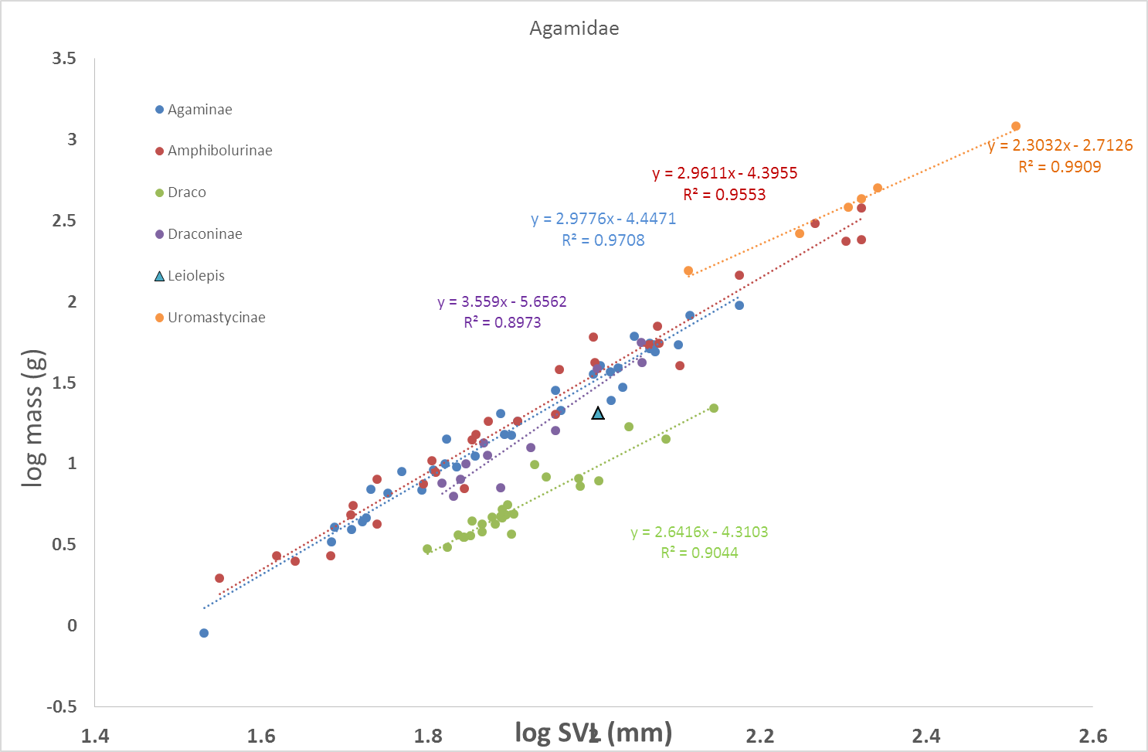

The genus *Draco* belongs to the sub-family Draconinae

1. A 3 taxon arrangement (with Urimastycinae separate from other agamids)

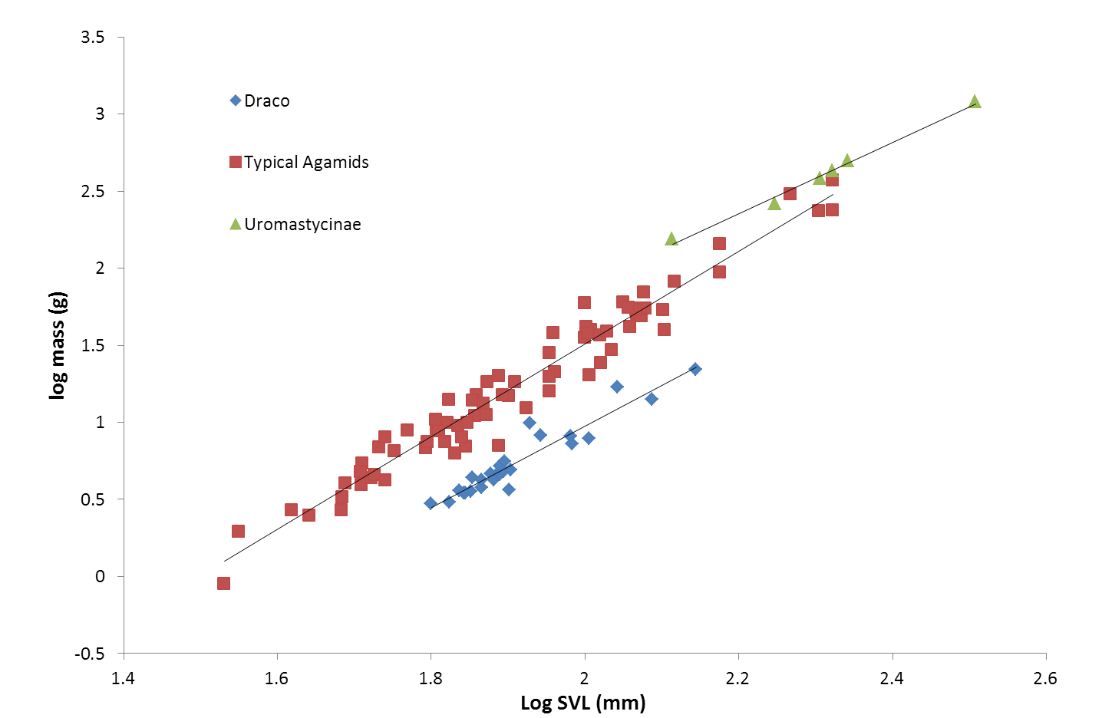

1. A 2 taxon arrangement (*Draco* and all other agamids)

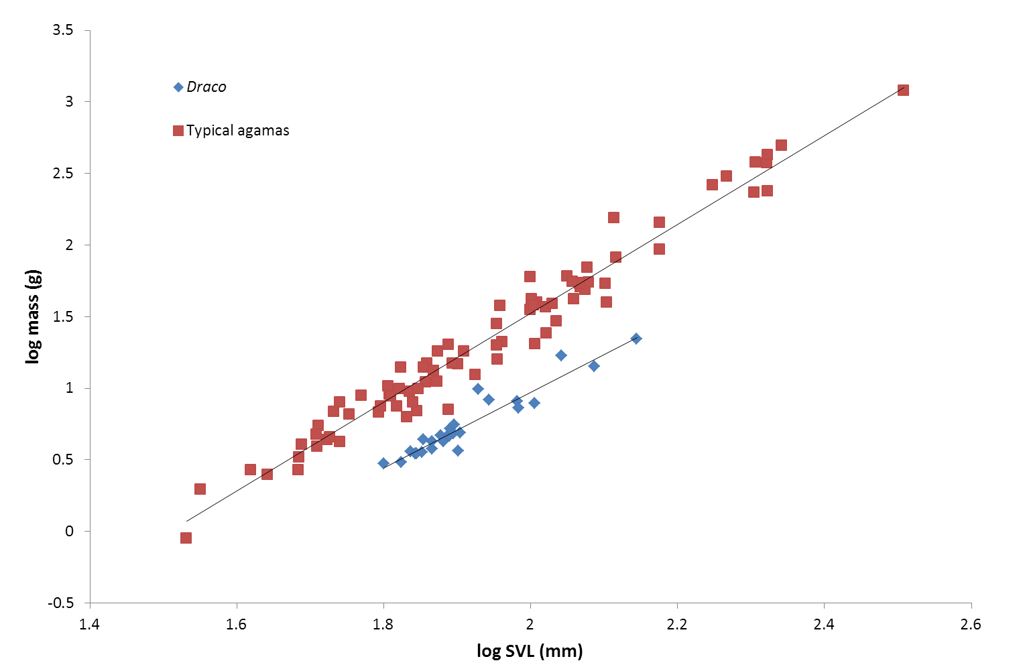

**Appendix S2c**

Examples of large differences in mass between squamates of a given length

|  |  |  |  |  |  |
| --- | --- | --- | --- | --- | --- |
| # | Species | sub-order | total length (mm) | mass (g) |  |
| 12473 | *Gerrhosaurus skoogi* | Sauria | 205 | 67.8 |  |
| 12734 | *Myriopholis macrorhyncha* | Serpentes | 206 | 0.6 |  |
| 6780 | *Daboia palaestinae* | Serpentes | 206 | 12.5 |  |
| na | *Platyceps collaris* | Serpentes | 224 | 19.5 | measured by SM in the field, 15/04/2015 |
| na | *Chamaeleo chamaeleon* | Sauria | 224.2 | 48.2 | measured by SM in the field, 25/05/2015 |
| na | *Myriopholis macrorhyncha* | Serpentes | 225 | 1.4 | measured by SM in the field, 29/05/2012 |
| 13991 | *Uromastyx ornata* | Sauria | 290 | 169.1 |  |
| 879 | *Myriopholis macrorhyncha* | Serpentes | 291 | 1.6 |  |
| 10 | *Eryx jaculus* | Serpentes | 291 | 27.3 |  |
| 14371 | *Uromastyx aegyptia* | Sauria | 500 | 1631 |  |
| 12117 | *Bitis caudalis* | Serpentes | 502 | 120.2 |  |
| 2871 | *Platyceps elegantissimus* | Serpentes | 503 | 11 |  |
| 5916 | *Cyclura nubila* | Sauria | 1022 | 3840 |  |
| 4517 | *Varanus griseus* | Sauria | 1064 | 1575 |  |
| 13098 | *Platyceps rhodorachis* | Serpentes | 1072 | 44.5 |  |
| 8089 | *Daboia palaestinae* | Serpentes | 1072 | 486.7 |  |
| 10506 | *Boa constrictor* | Serpentes | 2030 | 4480 |  |
| 3318 | *Dolichophis jugularis* | Serpentes | 2090 | 725 |  |

The left hand column is the museum number in the reptile collection of the Steinhardt Museum of Natural History, Tel Aviv University.

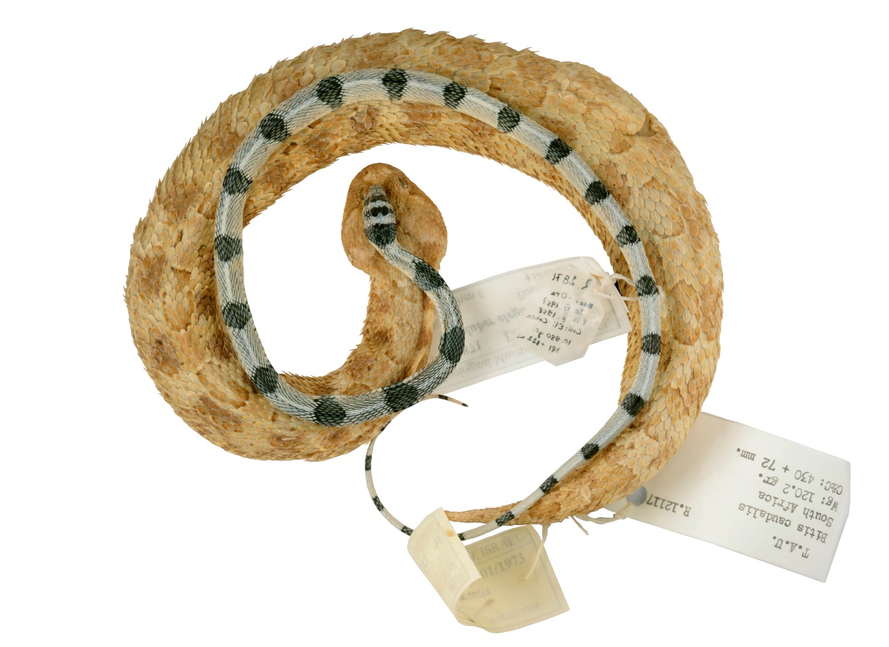

In the figure: *Bitis caudalis* #TAU12117 with the 1mm longer *Platyceps elegantissimus* #TAU2871 placed on top of it (photo: Oz Ritner, with permission) showing that similar lengths do not necessarily depict similar size even of snakes, hence making clade-specific length to mass conversion equations a necessity when comparing sizes of distantly related taxa.